PRESS RELEASE

4th April 2019

Mr Henrik Bos has been elected as the new ELCA-President
The European Landscape Contractors Association (ELCA) is continuing its successful expansion course with its new President Henrik Bos at the top. The European Landscape Contractors Association now has 24 members.

Change of leadership: Henrik Bos, Finland is the successor of Emmanuel Mony, France.
The ELCA-Presidium unanimously elected Henrik Bos, as the President of the European Landscape Contractors Association and the successor of Emmanuel Mony during its meeting of the Presidium in Nice - France. The French landscape gardening entrepreneur had significantly influenced the successful development of the ELCA during his nine years in office.

Since 2016 Henrik Bos (54) has been the Chairman of the ELCA-Committee of Firms.
Henrik Bos is a gardener and entrepreneur from Finland. He has been passionate about landscaping his whole life. From a young age he went abroad to work in other companies and when he was 18, he went to school to become a professional landscaper. He bought his father’s company in 1998 which he sold 5 years ago to the VRJ Group where he currently works. His company has been member of the ELCA for more than 30 years and he has come on many ELCA excursions.
Henrik is very active in the landscaping sector. Next to his business he is also member of the board of the Finnish Landscaping association, member of the board of the Finnish association of infrastructure constructions, Nordic landscaping board member and is a World Skills Expert and World Skills Skill manager in 2017.

Henrik Bos is supported by the re-elected ELCA Vice-Presidents Lutze vom Wurmb from Germany and Neil Huck from Great Britain. Emmanuel Mony have left the ELCA Presidium and the successor Catherine Muller is the first women to be the newly elected ELCA Vice-President. Catherine Muller is the President of the French landscape gardening association „Union Nationale des Entrepreneurs du Paysage (UNEP)“ and working for TM Paysage.

Henrik Bos is leaving as the Chairman of the ELCA-Committee of Firms. A written candidate survey and the election papers afterwards, will be sent to all the members of the ELCA-Committee of Firms. The result of the written ballot will be confirmed during the Presidium in October, Kraków - Poland by incorporating the chairman of the ELCA-Committee of Firms also as ELCA Vice-President.

New ELCA-President aims to realize ambitious goals
The new ELCA-President Henrik Bos wants to realize ambitious goals in the next three years.
His motto: „ Be part of the greenest network to create a greener world.” With dedicated lobby work with the ELCA he wants to especially push the message that Landscape contractors, work day-to-day on the implementation of multiple solutions to all the existing environmental green problems.
Henrik Bos: “Thank you for this opportunity. I feel humble to be part of this group and will do everything to fulfil the needs and expectations of the whole ELCA, Presidium, Associations and the Committee of Firms. My ambition is to develop international cooperation and to bring education and development to associations and companies in our trade. I believe that if the market is growing, good associations and companies are growing also. I believe that ELCA should go closer to his members. ELCA should also bring more value to its members so it can be more appealing to new members. The exchange of knowledge and vision of the associations and companies between countries is the biggest value of what ELCA can bring to its members.”

Close Research Gaps Surrounding Green
This is why Henrik Bos will set a further priority during his time as the ELCA-President: the research and solutions gaps surrounding green shall be closed. To achieve this internationally renowned scientists shall compile scientifically sound data about the positive effects of green – among other things on the health of people. In regard to questions concerning the climate they shall also research what effect vegetation has on the filtration of micro particles and as such on the improvement of air quality. With the ELCA Henrik Bos also wants to motivate the European Union to amend the EU research programmes correspondingly. Lobby work, the EU Green Week and the EU Green Year are his biggest priority for the forthcoming years.

The 24 Member Associations of the ELCA:
The full ELCA members currently amount to 22 national associations: Austria, Belgium, Bulgaria, Czech Republic, Denmark, Finland, France, Germany, Great Britain, Greece, Hungary, Ireland North, Ireland South, Italy, Luxembourg, Malta, Norway, Poland, Spain, Sweden, Switzerland, The Netherlands. The 2 associated members outside of Europe are Japan and Canada.

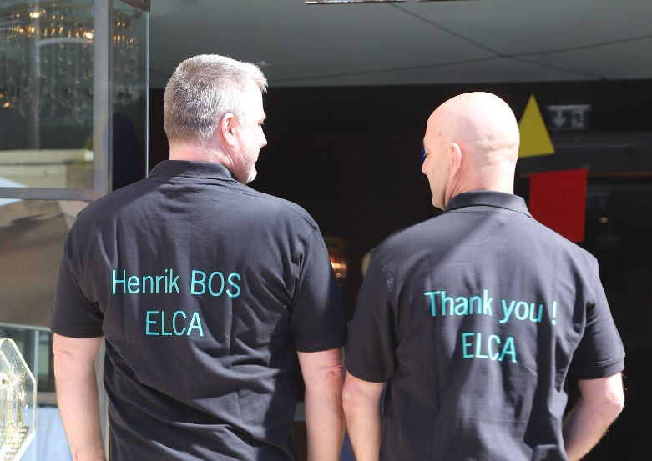

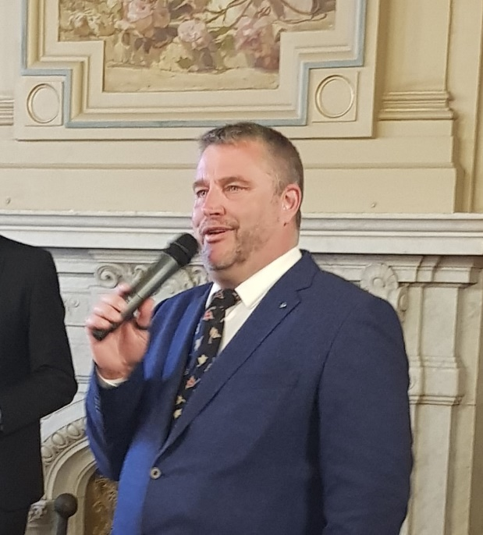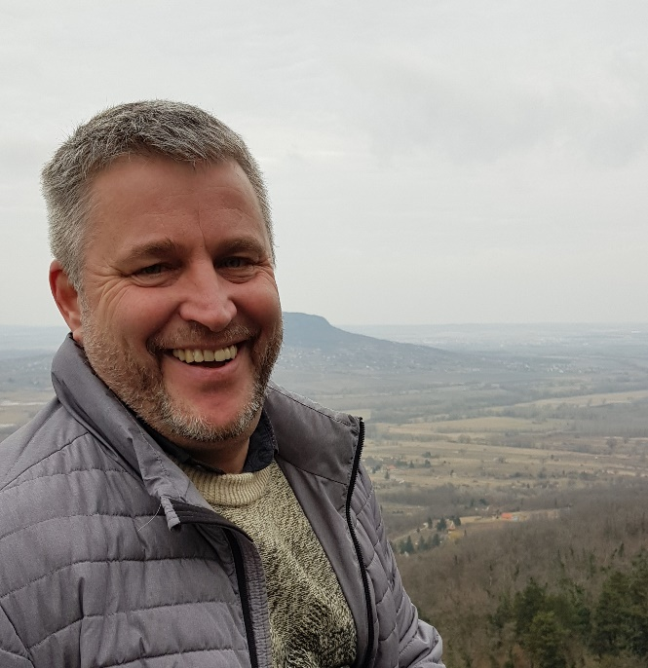

The ELCA-Presidium unanimously elected Henrik Bos (54) from Finland as the new President of the European Landscape Contractors Association.

